**DistroBox – Run Any Linux Distribution Inside Linux Terminal**

[Ravi Saive](https://www.tecmint.com/author/admin/)January 17, 2022 Categories [Fedora](https://www.tecmint.com/category/linux-distros/fedora/) [7 Comments](https://www.tecmint.com/distrobox-run-any-linux-distribution/#comments)

**Distrobox** is a nifty tool that allows you to create and manage containers on your favorite Linux distribution using either [Docker](https://www.tecmint.com/install-docker-and-learn-containers-in-centos-rhel-7-6/) or **Podman**. The launched container becomes highly integrated with the host system and this allows sharing of the user’s **HOME** directory along with external storage, USB devices, and graphical applications.

**Distrobox** is based on an **OCI** image and implements similar concepts to those of **ToolBox** which is built on top of podman and OCI standard container technologies.

In this guide, we will demonstrate how to install **DistroBox** to run any [Linux distribution](https://www.tecmint.com/best-linux-distributions-for-beginners/) inside your Linux terminal. For this guide, we are running **Fedora 34**.

**Prerequisites**

Before you proceed, ensure you have the following:

* Minimum podman version: 2.1.0 or docker version: 18.06.1.

**Step 1: Install DistroBox on Linux System**

Installing **DistroBox** is a piece of cake. Simply run the following [curl command](https://www.tecmint.com/linux-curl-command-examples/) which downloads and run the installation script.

$ curl https://raw.githubusercontent.com/89luca89/distrobox/main/install | sudo sh

[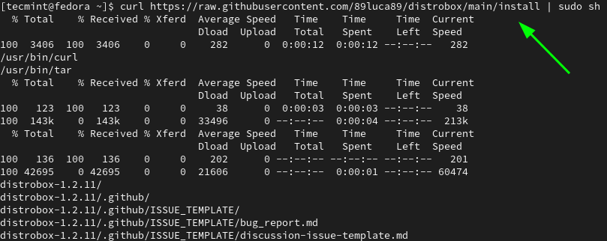](https://www.tecmint.com/wp-content/uploads/2013/01/Install-DistroBox-in-Fedora.png)Install DistroBox in Fedora

In **Fedora**, **DistroBox** is available from the **Copr** repository. So, enable the **Copr** repository on Fedora.

$ sudo dnf copr enable alciregi/distrobox

[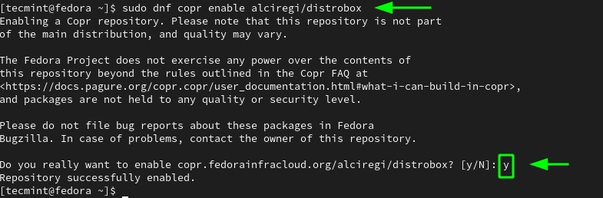](https://www.tecmint.com/wp-content/uploads/2013/01/Install-Copr-Repository-in-Fedora.png)Install Copr Repository in Fedora

Once the **Copr** repository has been added, use the [DNF package manager](https://www.tecmint.com/dnf-commands-for-fedora-rpm-package-management/) to install **Distrobox**.

$ sudo dnf install distrobox

[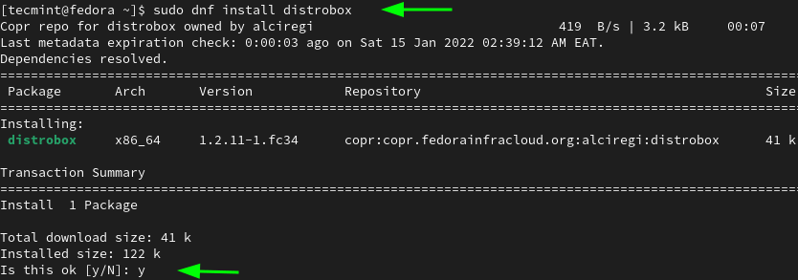](https://www.tecmint.com/wp-content/uploads/2013/01/Install-DistroBox-from-Copr-Repo-Fedora.png)Install DistroBox from Copr Repository

**Step 2: Create a Container from an Image**

With **Distrobox** installed, we can now get started with creating and running containers. To pull an image and run a container from the image, use the **distrobox-create** command as follows.

$ distrobox-create --name container-name --image os-image:version

In this example, we are creating a container called **debian10-distrobox** from the **Debian 10** image.

$ distrobox-create --name debian10-distrobox --image debian:10

The command pulls the **Debian 10** image from **Docker Hub** and creates a container called **debian10-distrobox**.

To get a complete list of operating systems and versions supported by Distrobox containers, visit the [Distrobox Project](https://github.com/89luca89/distrobox/blob/main/docs/compatibility.md#supported-container-managers) page.

[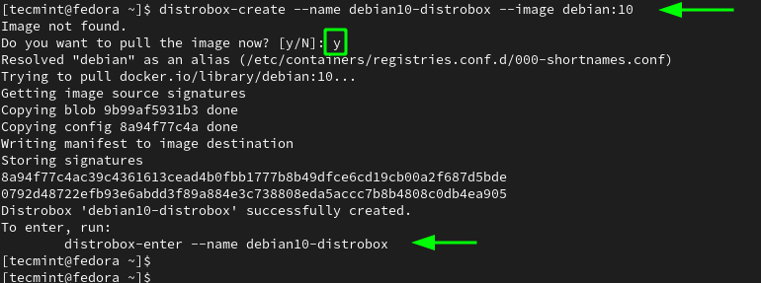](https://www.tecmint.com/wp-content/uploads/2013/01/Create-Distrobox-Container-Image.png)Create Distrobox Container Image

To list containers created with Distrobox, run:

$ distrobox-list

[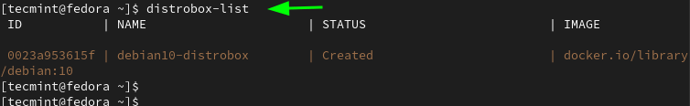](https://www.tecmint.com/wp-content/uploads/2013/01/List-Distrobox-Container-Images.png)List Distrobox Container Images

**Step 3: Accessing a Distrobox Container**

To access the shell of the newly created Linux container, use the **distrobox-enter** command as follows:

$ distrobox-enter --name container-name

For example, to access our container, we will run the command:

$ distrobox-enter --name debian10-distrobox

From here, you can run commands inside the container. For example, the following command checks the OS version.

$ cat /etc/os-release

[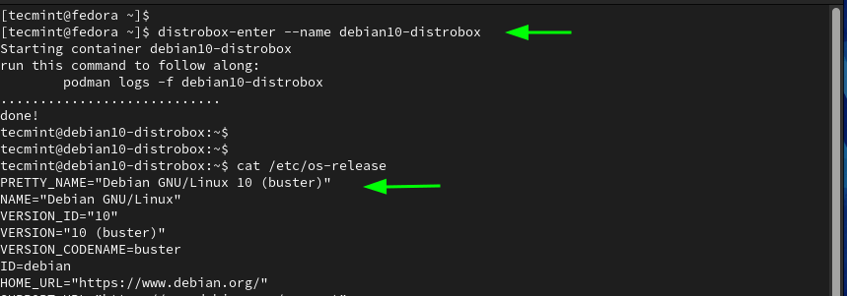](https://www.tecmint.com/wp-content/uploads/2013/01/Check-Distrobox-Linux-Container-Version.png)Check Distrobox Linux Container Version

You can also install applications. Here, we are installing the [Neofetch](https://www.tecmint.com/neofetch-shows-linux-system-information-with-logo/) utility tool.

$ sudo apt install neofetch

Once **Neofetch** is installed, launch it as follows.

[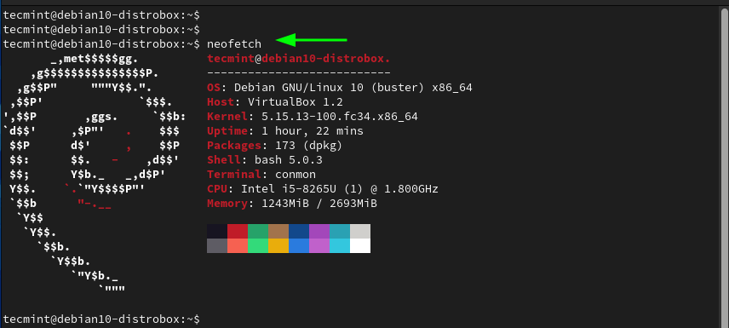](https://www.tecmint.com/wp-content/uploads/2013/01/Neofetch-Show-Linux-Information.png)Neofetch Show Linux Information

**Step 4: Run Commands On Distrobox Container**

You can directly run the commands on a Distrobox container instead of accessing the shell using the syntax shown.

$ distrobox-enter --name container-name -- command

In the following commands, we are displaying the uptime of the container and updating the package lists respectively.

$ distrobox-enter --name debian10-distrobox -- uptime

$ distrobox-enter --name debian10-distrobox -- sudo apt update

[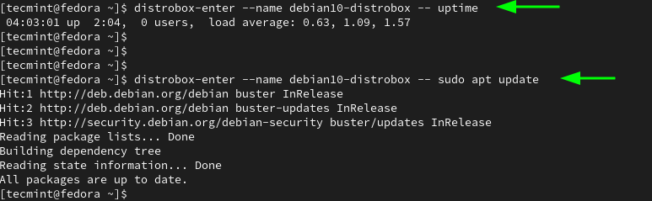](https://www.tecmint.com/wp-content/uploads/2013/01/Run-Commands-on-Distrobox-Linux-Container.png)Run Commands on Distrobox Linux Container

**Step 5: Exporting Applications from Container to Host**

In case you have an application inside the **Distrobox** container that you would like to port to the host system, you can do so using the **distrobox-export** command. Bur first, access the container’s shell.

$ distrobox-enter --name container-name

Here, we are going to install [Flameshot](https://www.tecmint.com/install-flameshot-in-linux/) which is a free and open-source cross-platform tool for taking screenshots.

$ sudo apt install flameshot

To export the application to **Fedora**, we will run the command:

$ distrobox-export --app flameshot

[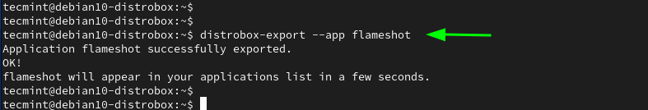](https://www.tecmint.com/wp-content/uploads/2013/01/Export-Applications-from-Container-to-Host.png)Export Applications from Container to Host

To exit the container, run:

$ logout

Now back to the **Fedora** host system. To confirm the existence of the application, we will run the search for the application using the Application menu as follows.

[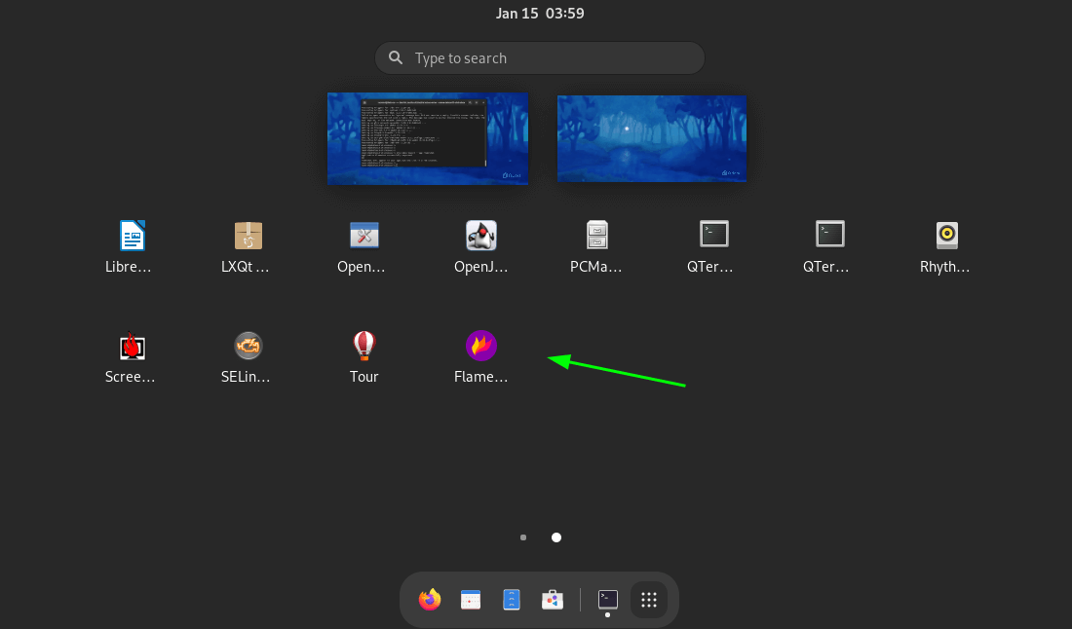](https://www.tecmint.com/wp-content/uploads/2013/01/Check-Exported-App-in-Fedora.png)Check Exported App in Fedora

**Step 6: Cloning a Distrobox Container**

Sometimes, you might need to create a duplicate or a clone of a container image. To achieve this, first, stop the running container using the **podman** command

$ podman stop container_ID

To get the container ID, run the **podman ps** command to list currently running containers.

$ podman ps

Once the container is stopped, you can create a duplicate as follows. In this example, we are duplicating the **debian10-distrobox** distrobox to a clone called **debian-10-clone**.

$ distrobox-create --name debian-10-clone --clone debian10-distrobox

[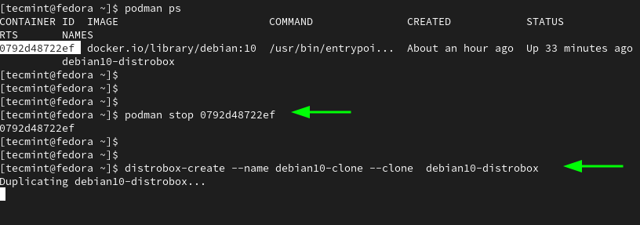](https://www.tecmint.com/wp-content/uploads/2013/01/Cloning-Distrobox-Linux-Container.png)Cloning Distrobox Linux Container

To confirm that the clone has been created, yet again, list the Distrobox containers as shown.

$ distrobox-list

[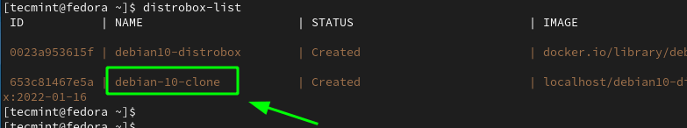](https://www.tecmint.com/wp-content/uploads/2013/01/List-Distrobox-Cloned-Images.png)List Distrobox Cloned Images

**Step 7: Managing Distroboxes in Fedora**

In this last section, we will briefly go over how to manage containers using **podman**.

To list all active containers, run:

$ podman ps

[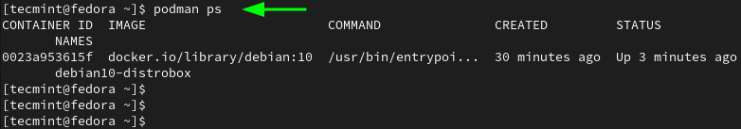](https://www.tecmint.com/wp-content/uploads/2013/01/List-Distrobox-Active-Containers.png)List Distrobox Active Containers

To list all running containers both active and those that have exited, run:

$ podman ps -a

To stop a container, run the command:

$ podman stop container_ID

To remove a container, be sure to stop it first and then remove it.

$ podman stop container_ID

$ podman rm container_ID

[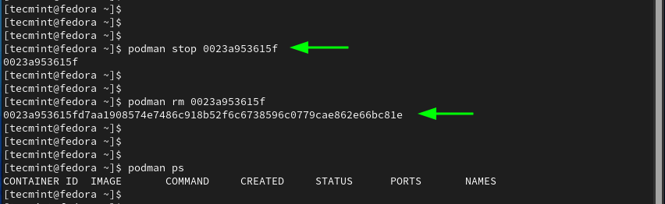](https://www.tecmint.com/wp-content/uploads/2013/01/Stop-Distrobox-Container-Images.png)Stop Distrobox Container Images

**Conclusion**

**Distrobox** is a handy utility that allows forward and backward compatibility with software applications and also enables you to try out various **Linux distributions** in form of containers without requiring sudo privileges.